**GANPAT UNIVERSITY**

**U.V.PATEL COLLEGE OF ENGINEERING & TECHNOLOGY**

**Department of Computer Science and Engineering**

**B.Tech 1ST Semester   Subject – ESFP**

**First Name:  Raj     Enrollment Number:                      Stream : BDA**

**Assignment -1                                                                                  Date: 27/08/2014**

**Deliverable:**

1. Write a program to print ASCII values of all backslash characters and white space on screen in following format :

The ASCII value of ‘\t’ is : 9

(Hint : you can verify your ASCII values with the help of a table for ASCII values from text book)

**Source:**

#include<stdio.h>

void main()

{

char BCC;

clrscr();

BCC='\a';

printf("The ASCII value of \'\\a\' is: %d\n",BCC,BCC);

BCC='\b';

printf("The ASCII value of \'\\b\' is: %d\n",BCC,BCC);

BCC='\f';

printf("The ASCII value of \'\\f\' is: %d\n",BCC,BCC);

BCC='\n';

printf("The ASCII value of \'\\n\' is: %d\n",BCC,BCC);

BCC='\r';

printf("The ASCII value of \'\\r\' is: %d\n",BCC,BCC);

BCC='\t';

printf("The ASCII value of \'\\t\' is: %d\n",BCC,BCC);

BCC='\v';

printf("The ASCII value of \'\\v\' is: %d\n",BCC,BCC);

BCC='\'';

printf("The ASCII value of \'\\\'\' is: %d\n",BCC,BCC);

BCC='\"';

printf("The ASCII value of \'\\\"\' is: %d\n",BCC,BCC);

BCC='\?';

printf("The ASCII value of \'\\?\' is: %d\n",BCC,BCC);

BCC='\\';

printf("The ASCII value of \'\\\\\' is: %d\n",BCC,BCC);

BCC='\0';

printf("The ASCII value of \'\\0\' is: %d\n",BCC,BCC);

}

**Output:**

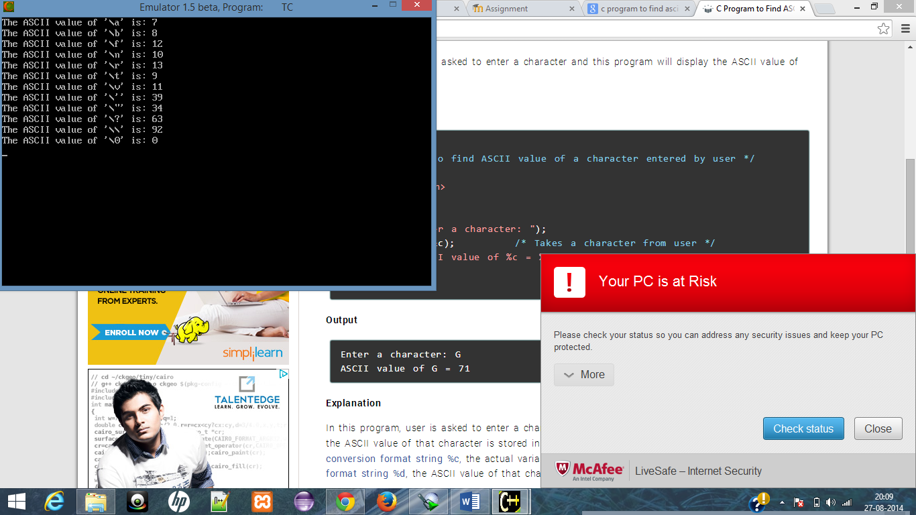

2. Explain different data types available in C.

**Ans:**

ANSII C supports three classes of data types:

1. Primary (or fundamental) data types:

|  |  |  |
| --- | --- | --- |
| **Type** | **Size(bits)** | **Range** |
| Char or signed char | 8 | -128 to 127 |
| Unsigned char | 8 | 0 to 255 |
| Int or signed int | 16 | -32768 to 32767 |
| Unsigned int | 16 | 0 to 65535 |
| Short or signed short int | 8 | -128 to 127 |
| Long or signed long int | 32 | -2147483648 to 2147483648 |
| Unsigned short int | 8 | 0 to 255 |
| Unsigned long int | 32 | 0 to 4294967295 |
| Float | 32 | 3.4E-38 to 3.4E+38 |
| Double | 64 | 1.7E-308 to 1.7E+308 |
| Long double | 80 | 3.4E-4932 to 1.1E+4932 |

Besides these data types there is also a **Void data tpes.** The void type has no value. The type of a function is said to be **Void** when it does not return any value to the calling function.

1. Derived data types
2. User defined data types

3. Explain about C Tokens in brief.

**Ans:**

In a passage of text, individual words and punctuation marks are called **tokens.** Similarly, in C program the smallest individual units are known as C tokens. C has six types of tokens as shown below:

4. Explain about backslash characters in C.

**Ans:**

C supports some basic some special backslash character constants that are used in output functions. A list of such backslash character constants is given in below table:

|  |  |
| --- | --- |
| **Constant** | **Meaning** |
| \a | Audible alert(bell) |
| \b | Back space |
| \f | Form feed |
| \n | New line |
| \r | Carriage return |
| \t | Horizontal tab |
| \v | Vertical tab |
| \’ | Single quote |
| \” | Double quote |
| \? | Question mark |
| \\ | Backslash |
| 10 | null |